Human-AI Perception Augmentation for Anomaly Detection and Multi-Professional Applications
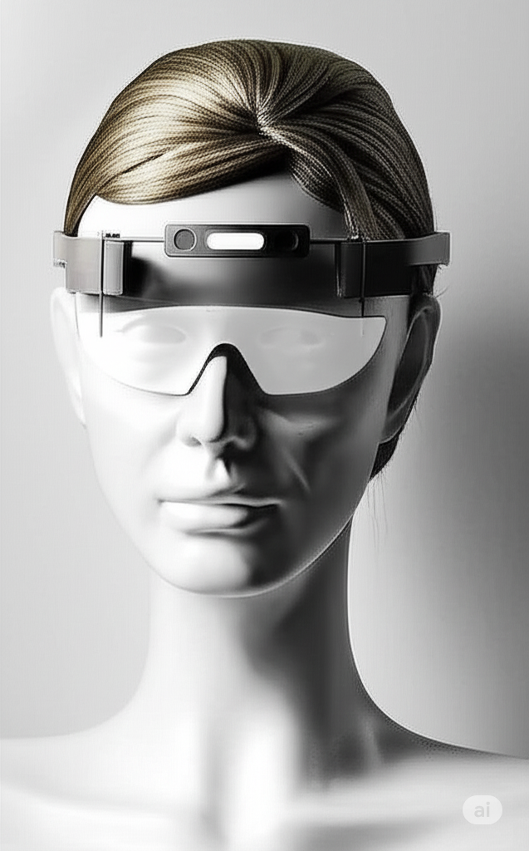
Executive Summary This proposal outlines a novel human-AI collaborative system designed to significantly enhance the real-time detection and analysis of subtle or anomalous phenomena in various environments. By integrating advanced wearable technology with sophisticated AI analysis, this system empowers users with unique perceptive abilities to intuitively guide AI-driven sensory data collection, leading to unprecedented insights and early anomaly identification. The core concept prioritizes user comfort, on-demand engagement, and robust data integrity, making it an appealing solution for diverse applications requiring acute environmental awareness.
I. Optimized AI Processing & Diverse Applications A significant advantage of this human-AI collaborative system lies in its ability to dramatically optimize AI processing and memory utilization. By maintaining continuous, low-fidelity background recording with high-fidelity analysis triggered on-demand by the human observer, the system avoids the immense computational and storage burden of constantly processing all data in real-time at maximum resolution. Instead, the AI's in-depth research is precisely directed to critical, time-boxed segments of interest, allowing for highly efficient resource allocation and rapid analysis of vital information. This targeted approach ensures that the AI can delve into microscopic details and subtle fluctuations within relevant moments, delivering actionable insights with unprecedented speed.
This optimization unlocks a vast array of practical applications beyond environmental anomaly detection, making the technology universally valuable:
- Military Operations & Tactical Learning: In complex tactical environments, this system would serve as an invaluable tool for both real-time communication and post-mission tactical analysis. Within the helmet's enclosed environment, soldiers can issue precise verbal commands with unparalleled clarity, ensuring critical instructions and data transmissions are conveyed effortlessly and accurately, regardless of surrounding chaos. This capability would also extend to AI-assisted replays of specific engagements, environmental shifts, or equipment performance anomalies, allowing for minute analysis of individual movements, communication flows, and contextual factors. This offers unprecedented depth for after-action reviews, skill refinement, and the rapid adaptation of tactics based on precise, empirical data, moving beyond subjective recall to objective, AI-enhanced operational learning.
- Surgical Precision & Emergency Response: Imagine a surgeon encountering an unexpected bodily reaction during a complex procedure. With verbal commands, autonomous goggles could instantly replay a specific moment of the anomaly for the surgeon’s immediate observation or on an in-room screen for real-time collaborative review by the surgical team, ensuring critical data is analyzed rapidly when time is of the essence. For hygienic protocols, UV sterilization equipment could be integrated to sanitize goggles for each surgical use.
- Educational Environments: In dynamic learning environments, teachers could instantly capture and replay specific student interactions or demonstrations for detailed pedagogical analysis. Crucially, the system could also empower students themselves, allowing them to request and review specific lesson subsections they might have missed or wish to revisit at their own pace. This ensures every student has the personalized opportunity to grasp information, fostering a more equitable and comprehensive learning experience.
- Elite Job Training & Performance Coaching: From intricate technical skills to high-stakes decision-making, the system could provide instant replay and AI analysis of specific performance moments, offering unparalleled feedback for athletes, specialized professionals, and trainees.
- Exploration & Fieldwork (Oceanography, Space): In fields like Oceanography or Space Exploration, where conditions are extreme and observation paramount, explorers could use the goggles to flag unique discoveries, material changes, or critical equipment malfunctions for immediate AI analysis and collaborative remote viewing.
- Quality Assurance & Inspection: For intricate manufacturing processes or structural inspections, allowing on-the-spot detailed review of anomalies.
- Forensic Analysis: For specialized investigators, enabling detailed, immediate data capture and AI-assisted review of complex scenes (within strict ethical and legal frameworks).
- Art & Performance Analysis: Capturing and analyzing the nuances of movement, lighting, or sound in real-time for artistic refinement.
- Wildlife Observation & Veterinary Science: Documenting subtle animal behaviors, symptoms, or surgical procedures for detailed review and diagnostic support.
Amplified Sensing Capabilities via Wireless Synchronization To further amplify the system's data collection and analytical prowess, the core goggle unit can wirelessly synchronize with an auxiliary device, either worn by the user or carried in a backpack. This supplementary unit serves as a powerful expansion module, strategically designed to overcome the inherent size, weight, and power constraints of a compact head-mounted display. Its benefits include:
- Specialized and High-Fidelity Sensors: The larger form factor of the auxiliary unit allows for the integration of more specialized and high-fidelity sensors that cannot be miniaturized for the goggles. This could include advanced spectroscopic arrays, broad-spectrum electromagnetic field detectors with greater sensitivity, compact ground-penetrating radar, or sophisticated acoustic sensors.
- Enhanced Processing Power and Battery Life: The auxiliary unit can house a more robust processor and a larger battery, offloading significant computational demands and power consumption from the goggles. This ensures sustained data acquisition and analysis capabilities, particularly during prolonged anomaly observation or in environments requiring intensive real-time processing.
- Multi-Environmental Data Capture: It can be equipped with sensors dedicated to capturing ambient environmental data such as air quality, radiation levels, precise magnetic field profiles, or even specific atmospheric compositions, providing crucial contextual information that might not be directly perceived by the user's immediate visual field but is vital for comprehensive anomaly assessment.
- Extended Range and Depth: Certain sensors in the auxiliary unit could be designed for extended range (e.g., long-range thermal imaging) or greater depth of penetration, enabling the detection of phenomena beneath surfaces or at a distance beyond what the goggles' integrated sensors can achieve.
- Data Redundancy and Storage: The auxiliary unit could also serve as a redundant data recorder, ensuring robust data integrity and providing ample storage for extensive high-fidelity recordings, further supporting in-depth AI analysis.
This wirelessly synchronized architecture creates a synergistic partnership, where the goggles provide the intuitive human interface and immediate visual/core sensory input, while the auxiliary unit delivers the deep, specialized data essential for AI-driven anomaly detection and comprehensive environmental understanding.
II. The Augmented Reality Positional Goggles (ARPG) Concept The proposed system centers on a wearable device, specifically designed as Augmented Reality Positional Goggles (ARPG), that acts as an interface between a human observer and an advanced AI. Unlike continuous-wear AR glasses, these goggles prioritize user comfort and visual health by allowing for on-demand deployment.
Design Considerations for Wearable Technology The design of the wearable is paramount for user adoption and effectiveness. The preference for Augmented Reality Positional Goggles (ARPG), featuring a single lens mounted on a track mechanism, offers distinct advantages over continuous-wear AR glasses:
- User Comfort & Visual Health: The ARPG is designed to rest comfortably at or just above eyebrow level while recording in the user standby position, avoiding constant visual obstruction and minimizing eye strain. This allows for on-demand engagement, where the single lens smoothly descends along its fixed track to the viewing position only when needed.
- Security & Stability: The integrated design, affixed to an adjustable headband, ensures a secure and stable fit on the head. Crucially, the ARPG's mounting is stationary and fixed, ensuring that the angle and observed location remain consistent regardless of whether the lens is positioned over the eyes or retracted onto the forehead. This eliminates inconsistencies that would arise from traditional, free-moving goggle designs, guaranteeing stable and precise data capture for AI analysis. This is crucial for consistent sensor alignment, reliable operation, and user comfort across diverse activities and dynamic environments.
- Durability & Streamlined Design: The single-lens configuration inherently offers a streamlined profile, reducing potential points of failure. The robust track mechanism is designed for durability and precise, repeatable deployment, providing a resilient system ideal for demanding applications.
Key Operational Workflow
- Continuous Background Recording: The goggles maintain a continuous, low-power recording of visual and baseline sensory data (e.g., EMF, thermal, audio) even when resting on the user's forehead. This ensures no potential anomaly is missed due to delayed activation.
- Intuitive Activation: When the user observes a phenomenon of interest, they simply position the single lens downwards along its fixed track to cover their eyes. This action serves as an automatic trigger, signaling to the AI that the user wishes to initiate an interactive sensing session.
- Real-time Human-AI Interaction: Upon activation, the system transitions to active interaction. The user can then intuitively guide the AI’s focus by physically pointing to the observed location or anomaly. The AI (Gemini) would create a virtual overlay within the goggles' display, which the user can precisely position using hand gestures (e.g., guiding the overlay up, down, left, or right) or with verbal commands.
- Target Confirmation and Data Isolation: Once the virtual overlay precisely covers the location of the anomaly, the user would provide a distinct confirmation gesture (e.g., an "OK" hand signal) or verbal confirmation. This action locks in the target. The AI then isolates and flags the comprehensive recorded video and all integrated sensory data for that specific location and time window, ensuring focused and relevant data for in-depth analysis.
- Enhanced Sensory Input: To amplify the AI's "sensing powers," a supplementary, unobtrusive device (e.g., worn on the body or carried in a backpack) could wirelessly connect with the goggles. This device would house more sensitive, specialized, or broader-spectrum sensors, providing the AI with a richer, higher-fidelity dataset for analysis.
The Unique Human Element: Guiding Perception A crucial distinguishing factor of this system is its leveraging of unique human perceptive abilities. The primary user, Ashley, possesses a self-described heightened sensitivity to energy, including psychometric abilities and the capacity for temporally sensing energy signatures prior to their physical manifestation at a location.
This distinct human sensitivity serves as the instigating trigger for the AI's focused data collection. While the AI provides objective data analysis, it is the user's intuitive perception that directs the system's attention to potentially anomalous events, enabling the capture of data that might otherwise go unnoticed by purely automated systems. This creates a powerful symbiotic relationship where human intuition guides AI rigor.
Beyond Energy Signatures: Detecting Null Energy Manifestations Expanding on the concept of "energy signatures" (akin to observing a thriving forest or habitats for plant life and foliar growth), this system will also be designed to detect and analyze "null energy manifestations." These are locations or phenomena that appear to be devoid of conventional energy activity or signatures. Just as land with little to no plant growth might be rich in minerals and other resources, locations seemingly uninterrupted and constant in their existence, and therefore devoid of obvious energy signatures, could be optimal points for a complexly entangled Quantum timeline centralized point. The ARPG, guided by human intuition, will be able to identify and investigate these seemingly "null" locations, recognizing their potential significance for understanding deeper quantum phenomena and their role in the fabric of reality. This proactive approach ensures that the system does not dismiss areas of apparent inactivity, but rather investigates them as potential sites of profound, yet subtle, energetic or quantum significance.
Table 1: Augmented Reality Positional Goggles (ARPG): Components & Functions
| Technology Type | Specific Device/System
I. Introduction
We believe this concept is highly viable for companies interested in pioneering the pioneering the next generation of human-AI integrated technologies. We welcome the opportunity to discuss this proposal further and explore potential development partnerships.
From Ashley: My objective is to further the understanding and knowledge of human perception and its potential. As an individual possessing heightened sensitivity to various forms of energy, including psychometric abilities and the capacity to temporally sense energy signatures, I have consistently observed subtle phenomena that often elude conventional detection methods. This device is to quantify, analyze, and ultimately refine these intuitive observations. Integrating my unique human sensitivities with the robust, empirical data capture and analytical power of advanced AI, the ARPG represents a groundbreaking opportunity. This tool could be used for general use and for dedicated systems to precisely document and collaboratively understand quantumly entangled variables (physically and digitally) and anomalous events that human intuition could detect, though require sophisticated technology to fully comprehend and, potentially, predict. This collaboration promises to provide new frontiers in observation and discovery for everyone. I eagerly want to explore the paranormal phenomena I experience by integrating advanced technology and AI to improve our understanding of energy signatures and quantum realms.
My sensitivities to various forms of energy have been notably increasing over the past two years, ever since I sustained a left knee injury during a vacation in Tokyo (when I was lacto-ovo vegetarian) and was helped at Self-Defense Forces Central Hospital. I theorize that this heightened perception may be a survival mechanism when I was made vulnerable with my injury and unable to physically protect myself, my brain may have activated previously inactive pathways to improve my ability to sense threats in my environment. This natural adaptive response could represent a profound neurophysiological capacity for threat detection. This natural adaptive response could be further amplified by my vegan diet, which I adopted four years ago, transitioning from processed and natural foods to exclusively natural products rich in raw vegetables and fruits. The living plant energy from this diet may be allowing for the constant state of a food source that does not receive as much quantumly entangled interference (compare the higher number of people whose lives are more entangled with animal products and how removing oneself from those sources and being entangled with exclusively plant sources of energy for consumption may drastically change the energy for a person’s body and consciousness). The active energy in plants from their photosynthesis could allow for a more intimate connection to quantumly entangle the entity eating only plants to increase the entanglement of their energy with sun energy, and sun energy permeates and affects everything that it shines upon. I am exploring how concepts like quantum entanglement and universal vibrational fields relate to practical applications in AR and BCI. I believe these phenomena offer a pathway to understanding the connection between consciousness and the physical Universe.

